**NEPAL COLLEGE OF INFORMATION TECHNOLOGY**

**BALKUMARI LALITPUR**



**(Affiliated To Pokhara University)**

**SUBJECT : Database Management System**

**LAB REPORT # 3**

**TITLE :** Data Query Language (DQL) Commands

**Submitted By : Submitted To :**

**Name :** Pradip Dhungana **Name :** Amit K. Shrivastava

**Roll No :** 201751 **Department of Software**

**Semester :** 4th  **Date :** 2023/06/20

OBJECTIVE

To practice and Implement data query language commands.

LAB EXERCISE :

* Creating a Database named ‘lab3’ and table called ‘employee’ with following structure :

|  |  |
| --- | --- |
| Column Name | DataType |
| eid | int |
| ename | varchar(20) |
| job | Varchar(20) |
| country | varchar(25) |
| city | varhchar(25) |
| salary | int |

= create database lab3;

= use lab3;

= create table employee(eid INT NOT NULL,ename VARCHAR(20) NOT NULL,job VARCHAR(20),country VARCHAR(25),city VARCHAR(25),salary INT NOT NULL);

**OUTPUT :**

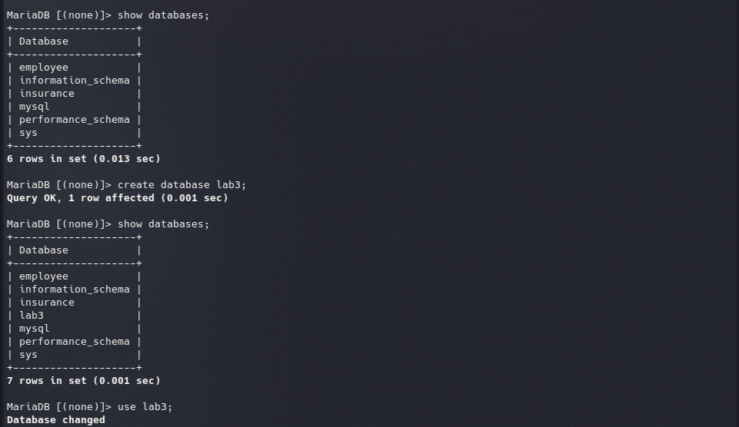

* Inserting values into ‘employee’ table :

= INSERT into employee VALUES(1,'Pradip','Manager','Nepal','Pokhara',20000),(2,'John','Programmer','Germany','Munich',5000),(3,'Bishnu','Doctor','Germany','Berlin',2500),(4,'Prabin','Banker','Germany','Hamburg',3400),(5,'Ujjwal','Analyst','Nepal','Makawanpur',1300),(6,'Harry','Engineer','Nepal','Dhampus',200),(7,'Sabin','Army','India','Delhi',2000),(8,'Ron','Manager','UK','Manchester',20000),(9,'Binod','Lecturer','India','Bihar',240),(10,'Madhav','Pilot','Finland','London',20000);

**OUTPUT :**



1) Select all information from employee table.

= SELECT * FROM employee;

**OUTPUT :**

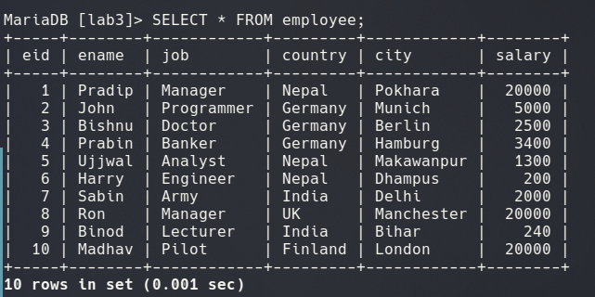2) Select employee name and job from employee table.

= SELECT ename,job FROM employee;

**OUTPUT :**

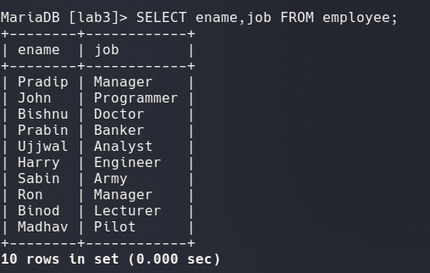3) Display all information from employee with country ‘Germany’ and salary greater than 2000.

= SELECT * FROM employee WHERE country = ‘Germany’ AND salary>2000;

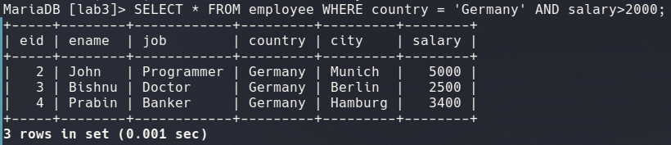**OUTPUT :**

4) Display name,country,job and salary of employee with either job is ‘programmer’ or ‘manager’.

= SELECT ename,country,job,salary FROM employee WHERE job IN(‘Programmer’,’Manager’);

**OUTPUT :**

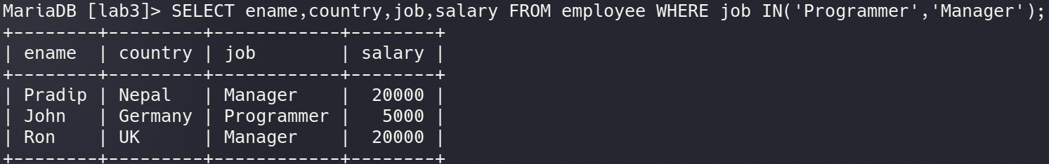5) Display all information from employee with country ‘Germany’ and city either ‘Munich’ or ‘berlin’.  
 = SELECT * FROM employee WHERE country = ‘Germany’ AND city IN(‘Munich’,’Berlin’);

**OUTPUT :**

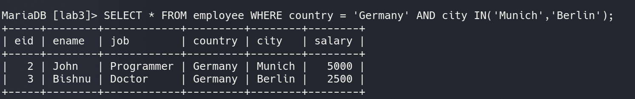6) Display all information form employee sorted in descending order.

= SELECT * FROM employee ORDER BY eid DESC;

**O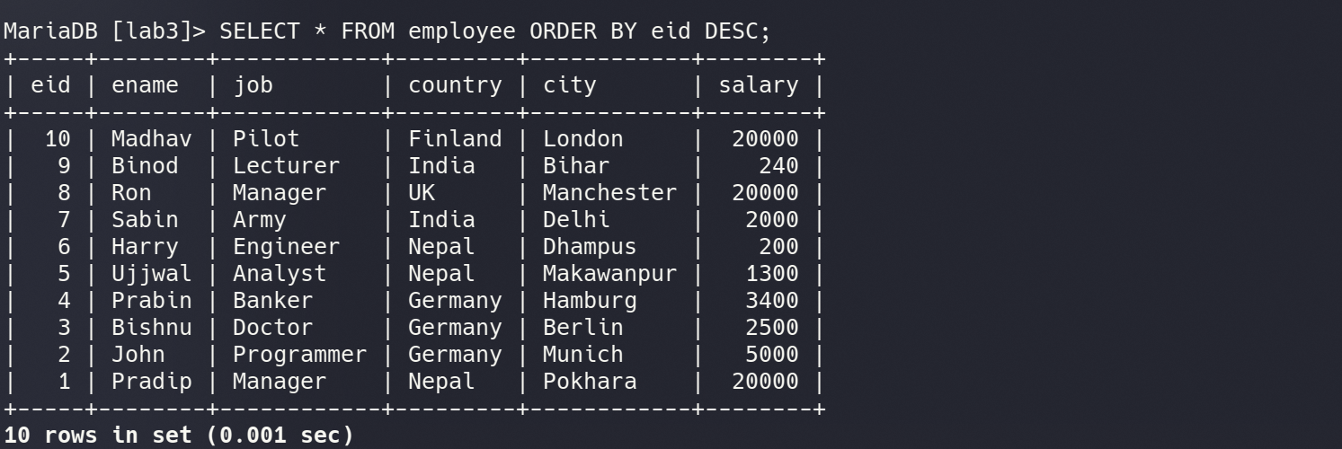UTPUT :**

7) Select all employees with name starting with letter ‘j’.

= SELECT * FROM employee WHEREename LIKE ‘j%’;

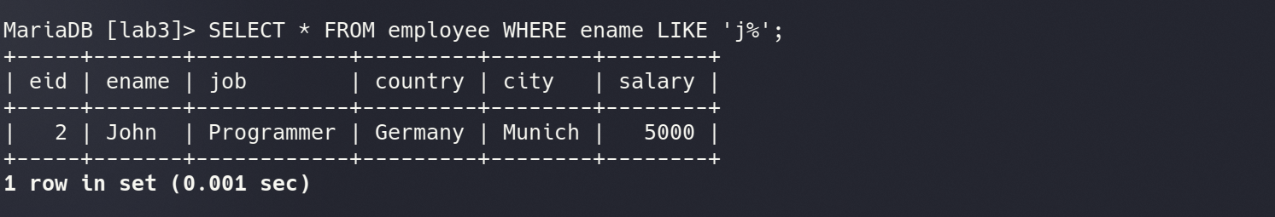**OUTPUT :**

8) Select all employees with country ending with letter ‘y’.

= SELECT * FROM employee WHERE country LIKE ‘%y’;

**OUTPUT:**

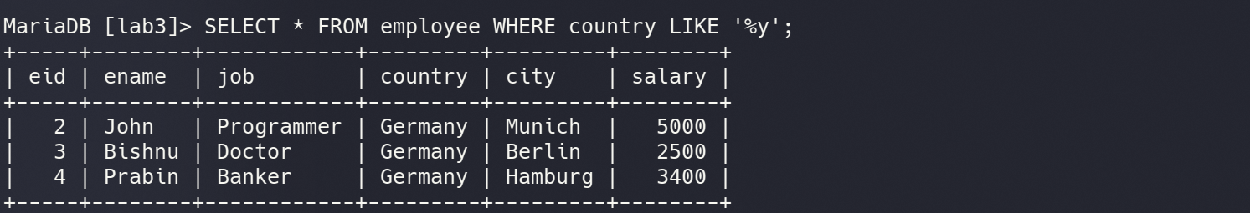9) Select all employees with country containing pattern ‘e’.

= SELECT * FROM employee WHERE country LIKE ‘%e%’;

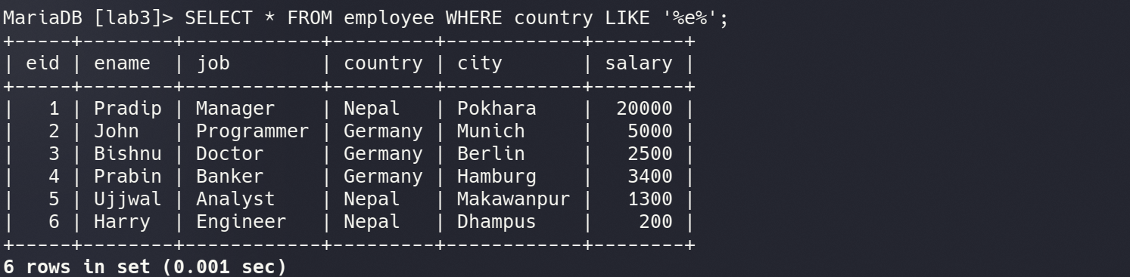**OUTPUT :**

10) Select all employees with country not containing pattern ‘land’.

= SELECT * FROM employee WHERE country NOT LIKE ‘%land%’;

**O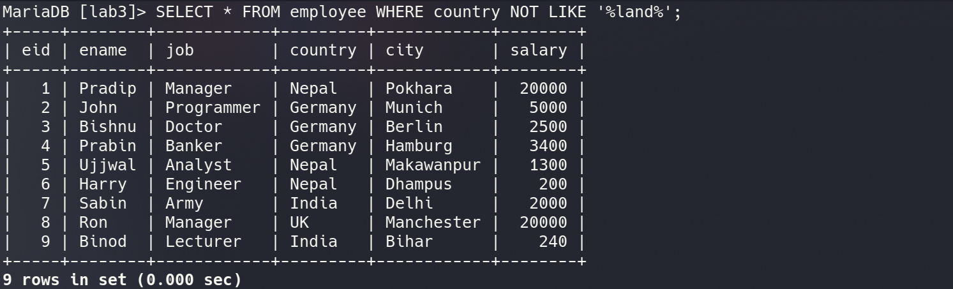UTPUT :**

11) Select all employees with city starting with any character followed by “erlin”.

= SELECT * FROM employee WHERE city LIKE ‘%erlin’;

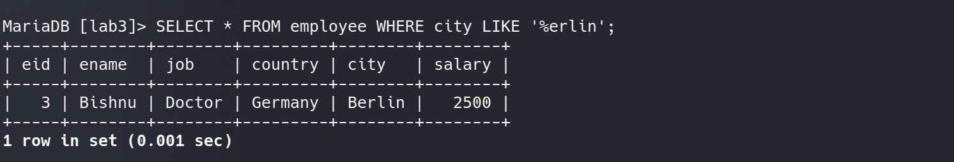**OUTPUT :**

12) Select all employees with a city starting with ‘l’, followed by any character, followed by ‘n’, followed by any character, followed by ‘on‘.

= SELECT * FROM employee WHERE city LIKE ‘l_n_on’;

**OUTPUT :**

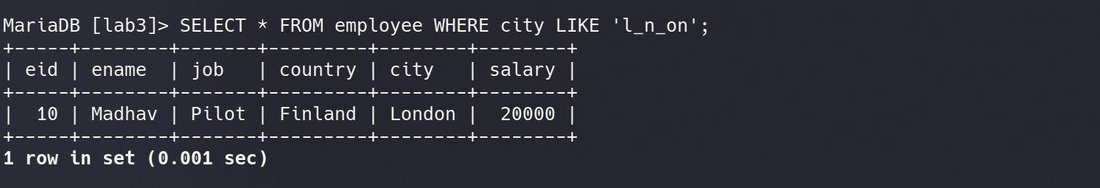13) Select all employees with a city starting with ‘b’,’m’ or ‘d’.

= SELECT * FROM employee WHERE city LIKE ‘b%’ OR city LIKE ‘m%’ OR city LIKE ‘d%’;

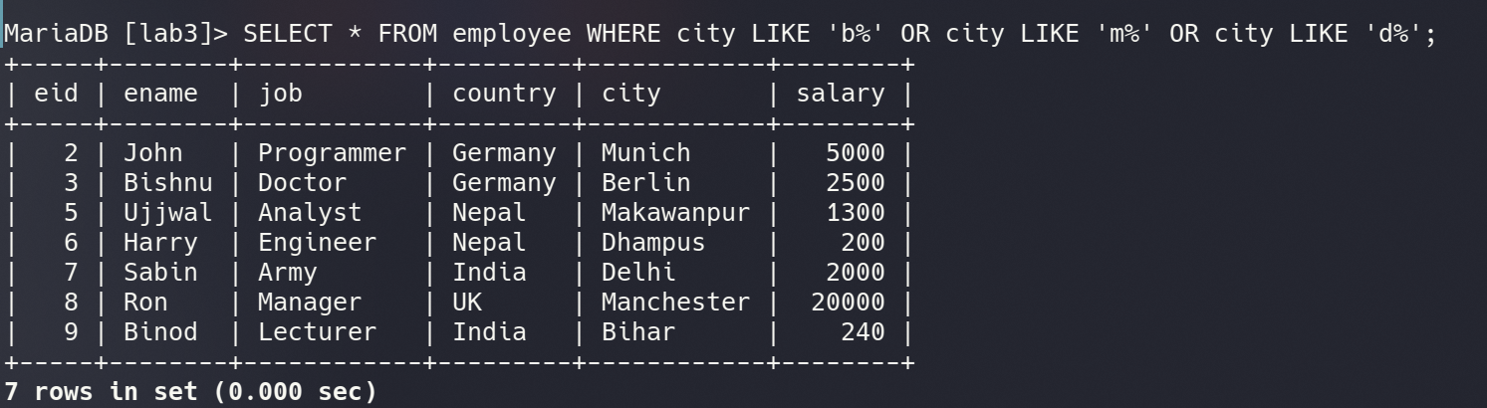**OUTPUT :**

14) Select all employees with a city starting with ‘a’,’b’ or ‘c’.

= SELECT * FROM employee WHERE city LIKE ‘a%’ OR city LIKE ‘b%’ OR city LIKE ‘c%’;

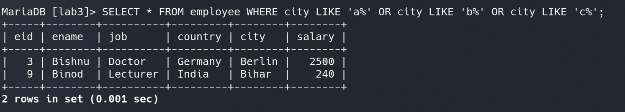**OUTPUT :**

15) Select all employees with a city not starting with ‘b’,’m’ or ‘d’.

= SELECT * FROM employee WHERE city NOT LIKE ‘b%’ AND city NOT LIKE ‘m%’ AND city NOT LIKE ‘d%’;

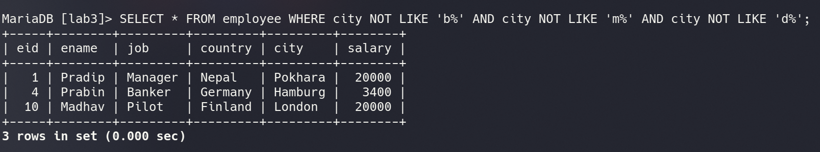**OUTPUT :**

16) Select all employees with a city of ‘Delhi’ or ‘Manchester’ use IN operator.

= SELECT * FROM employee WHERE city IN(‘Delhi’,’Manchester’);

**OUTPUT :**

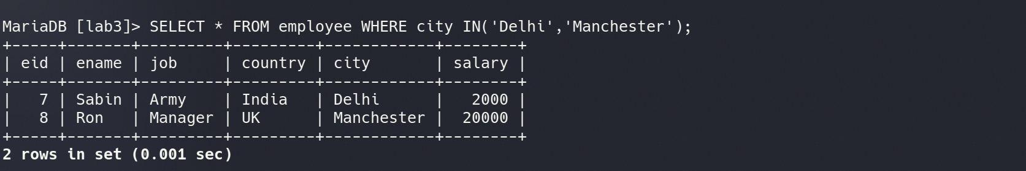17) Select all employees with salary BETWEEN 20000 and 35000.

= SELECT * FROM employee WHERE salary BETWEEN 20000 and 35000;

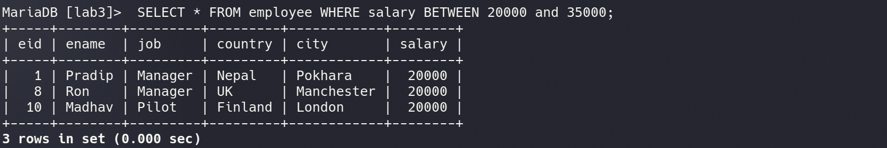**OUTPUT :**

18) Select all employees with salary BETWEEN 10000 and 40000, but employees with a ID of 1,2, or 3 should not be displayed.

= SELECT * FROM employee WHERE salary BETWEEN 10000 and 40000 AND eid NOT IN(1,2,3);

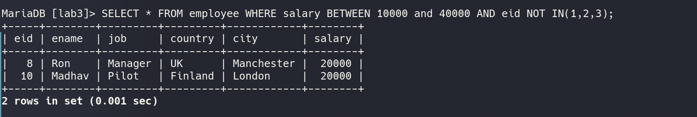**OUTPUT :**

19) Select all employees with city beginning with any of the letter BETWEEN ‘b’ and ‘m’.

= SELECT * FROM employee WHERE city BETWEEN ‘b’ and ‘m’;

**OUTPUT :**

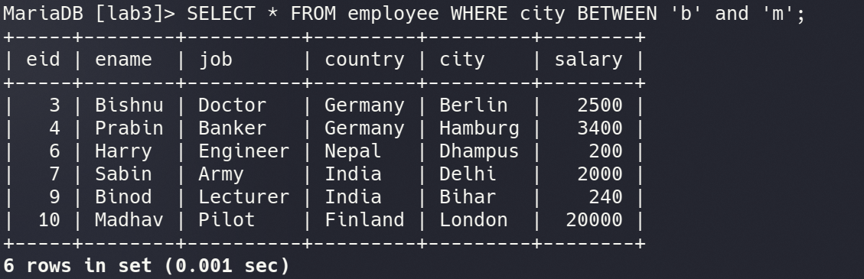

20) Select all employees with city beginning with any of the letter NOT BETWEEN ‘b’ and ‘m’.

= SELECT * FROM employee WHERE city NOT BETWEEN ‘b’ and ‘m’;

**OUTPUT :**

